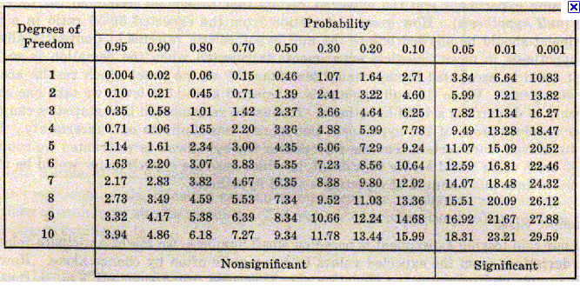
The chi-square distribution is commonly used to make inferences about a population variance.
If a population follows the normal distribution, you can draw a sample of size N from this distribution and form the sum of the squared standardized scores (chi-square). This random variable chi-square follows the chi-square probability distribution with n degrees of freedom (df ), where n is a positive integer equal to N-1. The degrees of freedom parameter determines the shape of the distribution. With more degrees of freedom, the skew is less.
CHIDIST
The CHIDIST function returns the area in the upper tail of the chi-square distribution. You use the CHIDIST function the same way you would use a chi-square distribution table. The CHIDIST function uses the following syntax:
=CHIDIST (x, df)
For example, if you pull a random sample of 16 from a population and want to find the probability of a sample chi-square value (x) 25 or larger, you would enter:
=CHIDIST (25,15)
The function returns the value 0.049943, meaning that a value of 25 or more should in the long run occur about five times in a hundred.
=CHIDIST(0.10,2) = 0.95
CHIINV
You can use the CHIINV function to create confidence interval estimates of a population variance. That is, you use the CHIDIST function if you know x and want to find the probability, and you use the CHIINV function if you have a probability and want to find x. For example, if you're creating a product and weigh a sample of 18 units to find a sample variance of 0.36, you may want to construct a 90% confidence interval estimate of the population variance for the product. With a sample size of 18, you have 17 degrees of freedom.
To find the upper limit, enter:
=CHIINV (0.95,17)
To find the lower limit, enter:
=CHIINV (0.05,17)
These formulas return the values 8.67175 and 27.5871. Multiply the sample variance of 0.36 by the degrees of freedom and divide this product by each of the values returned from the CHIINV function to find the lower and upper limits of the confidence interval. You can take the square root of these values to establish interval estimates of the population standard deviation.
CHITEST
The chi-square test is used to test independence of two variables. You can use the chi-square test to determine whether there is a significant difference between observed and expected frequencies. For example, if you want to find out whether soft drink preference differs between male and female drinkers, you can construct a null hypothesis that soft drink preference is independent of the gender of the drinker, and create a worksheet range, or table, of expected results based on a sample of 93 male drinkers and 85 female drinkers. You can then create a table of the results of the actual study findings.
TIP: You can use the Microsoft Excel Fisher's test function instead of the chi-square test for analyzing contingency tables with two rows and two columns. Fisher's test always returns the exact P value, whereas the chi-square test returns only an approximate p value. Definitely avoid the chi-square test when the numbers in the contingency table are very small (in the single digits).
The CHITEST formula uses the following syntax:
=CHITEST (actual range, expected range)
where actual range is the data in the actual sample results table and expected range is the data from the expected results table.
The formula returns the p-value. You reject the null hypothesis if this value is less than your level of significance alpha. So if your level of significance is .05, you would reject it, but not if your level of significance is .025 or .01. The test for independence is a one-tailed test, so a level of significance of .05 corresponds with a 95% confidence level.

 | Trident | Carefree | Extra
Observed | 10 | 3 | 2
Expected | 5 | 5 | 5

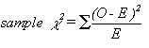

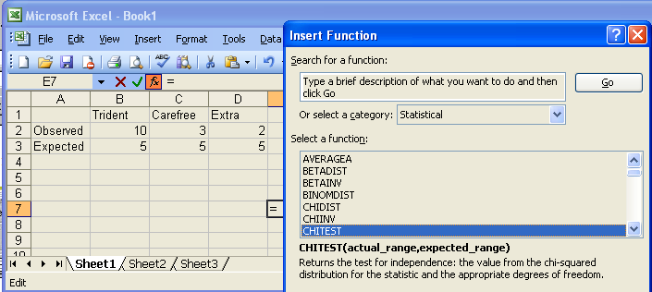

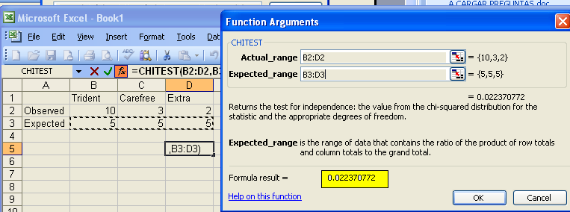

INTERPRETATION OF RESULTS
df = (filas -1)(columnas-1) = 2
If | Then
p value < α | Reject the null hypothesis
p value > α | Accept the null hypothesis
In the above results the p value = 0.0223 which is dramatically lower than our alpha value of 0.05, so, we can reject the null hypothesis that the sample is fair.
At the 5% level (95% confidence level) the critical Chi-Squared for df = 2 is 5.99 5.6 > 0.0223
=CHIINV(0.05, 2) = 5.99
For one degree of freedom (df=1), we need a χ² of 3.841 (5.99) or greater in order to say that the data is significant at P < 0.05. In our example, χ² is 1.42 (0.0223), so it is not statistically significant.
In this case, we cannot claim with much confidence that the differences we see in this sample are generalizable to the population at large.

Valores Actuales | Sobre 50 | Abajo de 50
De acuerdo | 30 | 38
Neutro | 40 | 20
Desacuerdo | 10 | 22
Valores Esperados
De acuerdo | 34 | 34
Neutro | 30 | 30
Desacuerdo | 16 | 16

CHITEST(B2:C4, B6:C8). = 0.002348634
df = (filas -1)(columnas-1) = 2
Y porque el valor es mucho menor que 0.01, podemos constatar que la edad es un factor en cómo los empleados ven la nueva política.
DF =2 a 0.01 => 9.21

In the sample given below, there are 300 females and 200 males. Is there a significant difference between males and females in their likelihood of being in poverty?

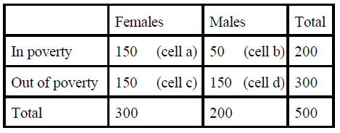

X2 = 15 + 5 + 11.25 = 31.25

At 1 DF for a 2-tailed test, the cv is 3.84. Since the chi-square value is greater than the CV, reject.

